How to Password Protect Windows 7 User Account
Article Source: http://recoverlostpassword.com/article/password-protect-windows-7.html
Did you share your computer with someone else? Even in this modern world where most of us have our own computer, we are probably meet up with sharing or need to access a shared computer. When this happened, it is necessary to have a separate account and create a strong password for it. Creating a password can keep our personal data and files private and secure from unauthorized access, Password protecting windows user accounts is easy to do in Windows 7, and the process is pretty much the same as Windows Vista.
In this article, we look at two options for you to create a password for Windows 7 user account so that the next time anyone get access to your windows 7 system should enter a password firstly.
Note: If you have created a strong password for your Windows 7 user account but now forgot Windows 7 password and can’t get access to your system, see related article on how to find out a forgotten Windows 7 Password.
OPTION ONE:
Create a password for Windows 7 administrator account, here is how:
Step 1: Open Control Panel
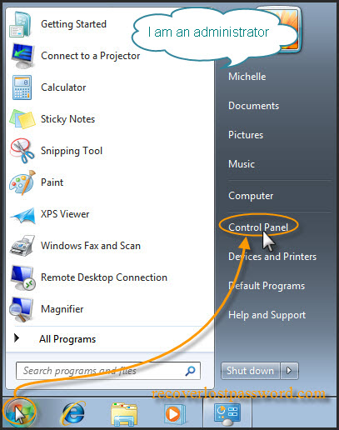
Click on Start button, the Windows Orb and then choose Control Panel.
Step 2 Open User Accounts
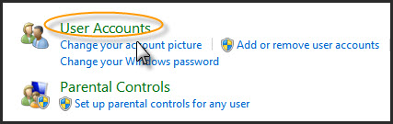
Click on the User Accounts and Family Safely option, and then click on User Accounts icon.
Step 3: Create a password for your Windows 7 user account
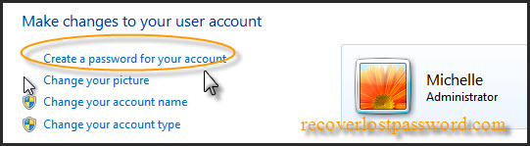
Click on the Create a password for your account link.
Step 4: Assign a new password
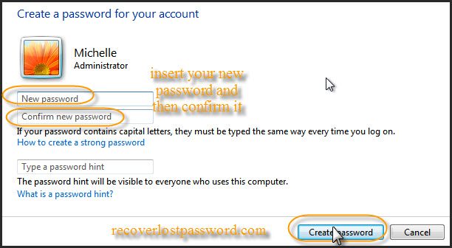
Insert your new password and then Confirm new password, finally click on the Create Password button.
Note: If you are afraid of forgetting Windows 7 password, you can type a password hint to get reminded of your password. If you do not want a password hint, then you can skip that field.
WARNING: Remember that anyone using the computer will be able to see the password hint.
Step 5: All done!
Your Windows 7 User Account is now Password protected.
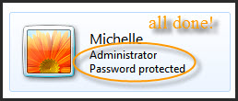
OPTION TWO:
Create a Password for another User Account, here is how:
NOTE: Only Use account with administrator authority has permissions to do this.
Step 1 to step 2 is the same as above.
Step 3: Manage another user account password
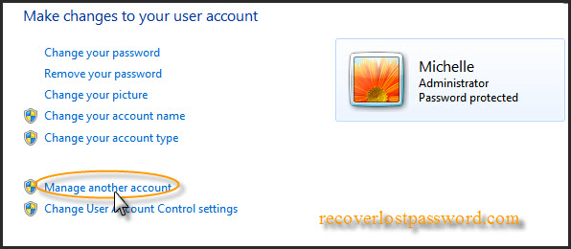
Click on the Manage another account link.
Step 4: Select user account
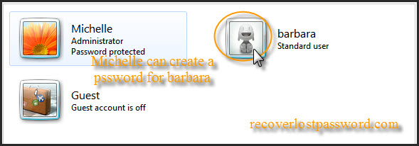
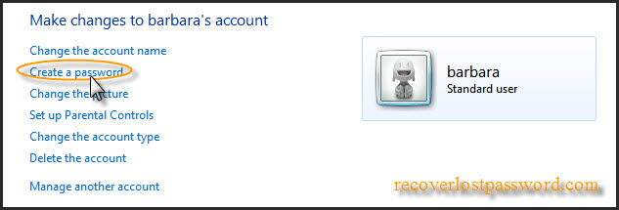
Click on the account that you wish to create a password for, and then click Create a password link.
Step 4: Assign a new password
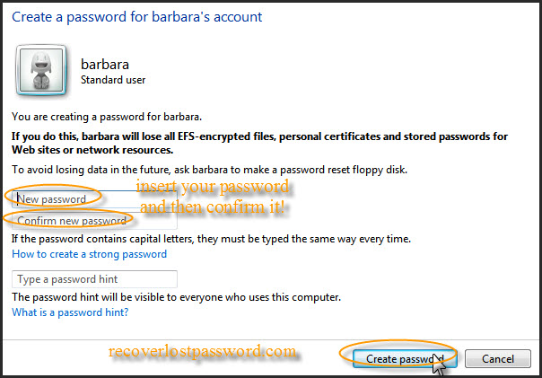
Type in a new password and then again to confirm new password, finally click on the Create Password button.
Step 5: The other Account is now Password protected.
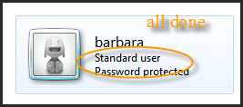
You have successfully created a password for Windows 7 another User Account.
That's all!

